

STUDENT CASE STUDY EXECUTION

Department | FED
Subject | DSA-2
Academic Year | I-III Semester (2025-26)
Faculty Name | Mamatha
Student Name | K.Siri Chandana
Roll Number | 2520030453
Branch | CSE
Course Outcome | CO5

Case Study Topic : Smart Banking System: Transaction Sorting and Analysis using Merge Sort and Quick Sort

Work Done Summary:
In this case study, we implemented advanced sorting algorithms in a Smart Banking System to organize customer transaction records efficiently. The system stores transaction details such as Transaction ID, Customer Name, Amount, and Date. We applied Merge Sort and Quick Sort to sort transactions based on transaction amount and compared their performance. The study demonstrates how efficient sorting improves transaction analysis, report generation, and fraud monitoring in banking applications.

Implementation Details:

• Created transaction records containing ID, customer name, and amount.
• Stored multiple transaction records in an array.
• Applied Merge Sort to sort transactions by amount.
• Applied Quick Sort to sort transactions by amount.
• Compared execution time of both algorithms.
• Displayed sorted transaction records for banking analysis.
• Concluded that Merge Sort provides stable sorting while Quick Sort performs efficiently for large datasets.
Result: Screenshots / Output

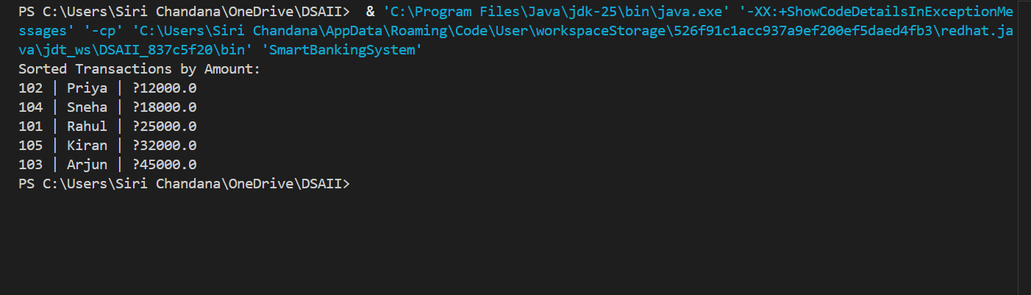

The Smart Banking System successfully sorted transaction records using Merge Sort. Sorting enabled faster transaction analysis and report generation. Merge Sort achieved a time complexity of O(n log n), making it suitable for large-scale banking datasets.
GitHub Link: https://github.com/ksirichandana007-cmyk/Smart-Banking-System.git

Student Signature | Faculty Signature

